# **St. Matthew’s Episcopal Church**

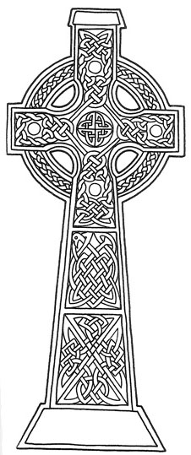

**Sunday, April 24, 2022**

**Second Sunday of Easter**

**Communion in the Absence of a Priest**

**Worship at 10:15am**

**In-person & Facebook Live**

**Facebook.com/stmattsnewton**

**Website:** **stmatthewsnewton.org**

**Prelude**

**Processional Hymnal # 616**

**“Hail to the Lord’s anointed”**

**Opening Acclamation**

Minister of the Word: Grace and peace. In the name of Christ.

People: **Thanks be to God.**

**The Ministry of the Word**

Collect of the Day BCP pg. 224

## First Lesson *(sit)* Acts 5:27-32

## Psalm 150 BCP pg. 807

## Second Lesson Revelation 1:4-8

**Sequence Hymn** (*stand)* **Hymnal #58 vs 1-2**

**“Lo! He comes with clouds descending”**

Gospel Luke 5:1-3, 11b-32

**Sequence Hymn** (*stand)* **Hymnal #58 vs 3-4**

**“Lo! He comes with clouds descending”**

Proclamation (*sit*) Deacon Barbara Gibson

Nicene Creed BCP pg. 358

Prayers of the People Form IV BCP pg. 388

Prayer for National Life BCP pg. 820

Prayer for Peace BCP pg. 816

The Concluding Collect

The Confession BCP pg. 360

The Peace (*stand*) BCP pg. 360

**Announcements**

Offertory

**Doxology Hymnal #380 v.3**

**We Prepare the Table and Share the Gifts of God**

The Lord’s Prayer BCP pg. 364

The Prayer of Humble Access BCP pg. 337

Communion

**Post Communion Hymn Hymnal #178**

**“Alleluia, Alleluia! Give thanks”**

Post Communion Prayer

**Loving God, we give you thanks for restoring us in your image and nourishing us with spiritual food in the Sacrament of Christ Body. Now send us forth a people, forgiven, healed, renewed; that we may proclaim your love to the world and continue in the risen life of Christ our Savior. *Amen***

**Recessional Hymnal # 450**

**“All Hail the power of Jesus’ name”**

Dismissal

Postlude

**Ministers this Service**

**Minister of Reserved Sacrament:** The Rev. Barbara Gibson, *Deacon*

**Minister of the Word:** Maggie Snow

**Lector:** Bonnie Jones **Organist:** Kelli Glann

**Videographer :** Ben Teichler

**Altar Guild:** Chris Simmonds, Katie Reese, Elizabeth Hill, Margie Knupp

**Host:**

**Lessons for May 1, 2022**

First Lesson Acts 9:1-6

Psalm 23

Second Lesson Revelation 5:11-14

Gospel John 21:1-19

**Calendar**

Wednesday Evening Prayer 6:30 p.m.  
 EfM 7 p.m.

Friday A.A. meeting, lounge 6 p.m.

# St. Matthew’s Episcopal Church

2001 Windsor Drive

P.O. Box 342

Newton, Kansas 67114

The Reverend Richard Osborne

928-925-8818